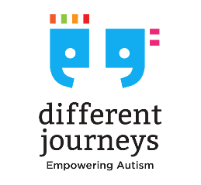
Different Journeys
Statement of Purpose

Different Journeys has been established to be a benevolent not for profit charity that advances social and public welfare and promotes the Human Rights of autistic people and their families.
The purposes are:
- To provide social platforms that connect autistic people and their families in inclusive, safe and supportive environments.
- To provide individualised wraparound supports to decrease the prevalence of mental illness and social isolation in the autism community and to enhance the employment and education opportunities of autistic youth and autistic adults and their families.
- To create supportive environments in which the broader community can embrace, learn from and empower the autism community to the benefit of the general public.
- To facilitate opportunities for autistic people and their families to interact with other people and have the same life experiences as people who are not autistic to the benefit of the general public.
- To build supportive inclusive communities that empower autistic people and their families and networks.
- To provide social platforms that foster positive connections, build peer relationships and share skills for autistic youth and autistic adults and their families.
- To facilitate community inclusion and tackle isolation of autistic people and their families.
- To provide families of autistic people with understanding, fellowship and information.
- To link autistic people and their families into services and supports.
- To redress disadvantage by informally advocating and challenging the things that limit or “disable” Autistic people.
- To mentor and train autistic people and their families.
- To mentor and train the broader community in relation to engaging with and supporting autistic people and their families.
- To promote and protect human rights by acting as an advocate for autistic people and their families in relation to their rights under the Convention on the Rights of Persons with Disabilities.
- To provide accurate community information and make informed referrals to support providers.
- To involve autistic people and their families and members of the community in the Association through volunteer-based service provision, community-based management and volunteer administrative and fund-raising activities.
- To engage in activities that facilitate high standard volunteerism; contribute to the general community; share resources with other service providers and support co-operative community development and service provision.
- To deliver a well-planned and secure financial base for the operation of the Association.

